GIST OF ELITE OF APRDC ALUMNI

ALUMNI MEMBERS IN CIVIL SERVICES

K.Sreenivasa Reddy, IPS | Addl. DGP Operations (Grey Hounds & Octopus), Telangana | 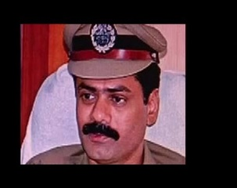
M.Nagaraju IAS | Additional Secretary, Govt. of India, Min. of Coal, New Delhi | 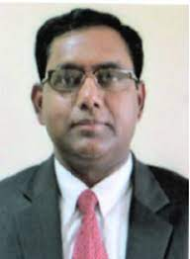
M.Harishchandra Naik IRS | Commissioner of Income Tax (Appeals), Trissur. | 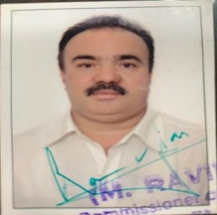
V. Ram Manohar Rao IRAS | Special Secretary to Government of Andhra Pradesh, Municipal Administration & Urban Development | 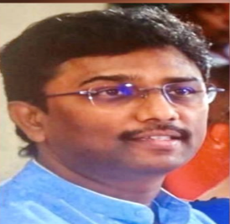
Mr.J.Meghanath, IRAS

Public Service & State Services:
M.Shankar Narayana | Minister for Roads & Buildings, Government of Andhra Pradesh | 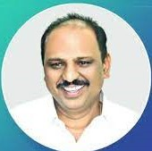
S.Harikrishna | Vice-Chairman, Tirupati Urban Development Authority | 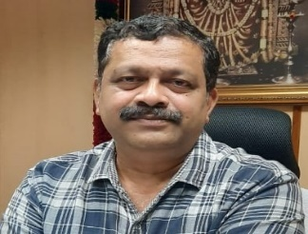
Y.Chaitanya Murali | Deputy Commissioner, Excise & Prohibition, Government of Andhra Pradesh
Ch. Laxminarayana | Additional SP,  Government of Telangana | 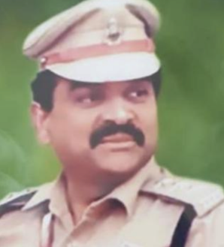

- More than 50 Alumni members are providing academic services as Professors & Associate Professors in various universities across India viz., Central University of Hyderabad; Banaras University; Pondicherry University; Osmania University.
- More than 200 Alumni members are in the professional fields like Chartered Accountants, Company Secretaries, Software Engineers, Indian Statistical Services, Cost Accountants, Advocates and alumni is proud to have some members in the Judiciary also.
- More than 50 Alumni members are rendering their services outside India.
- Good number of Alumni members are working with Banks, Public Sector undertakings, Private Organizations and some have established educational institutions.

